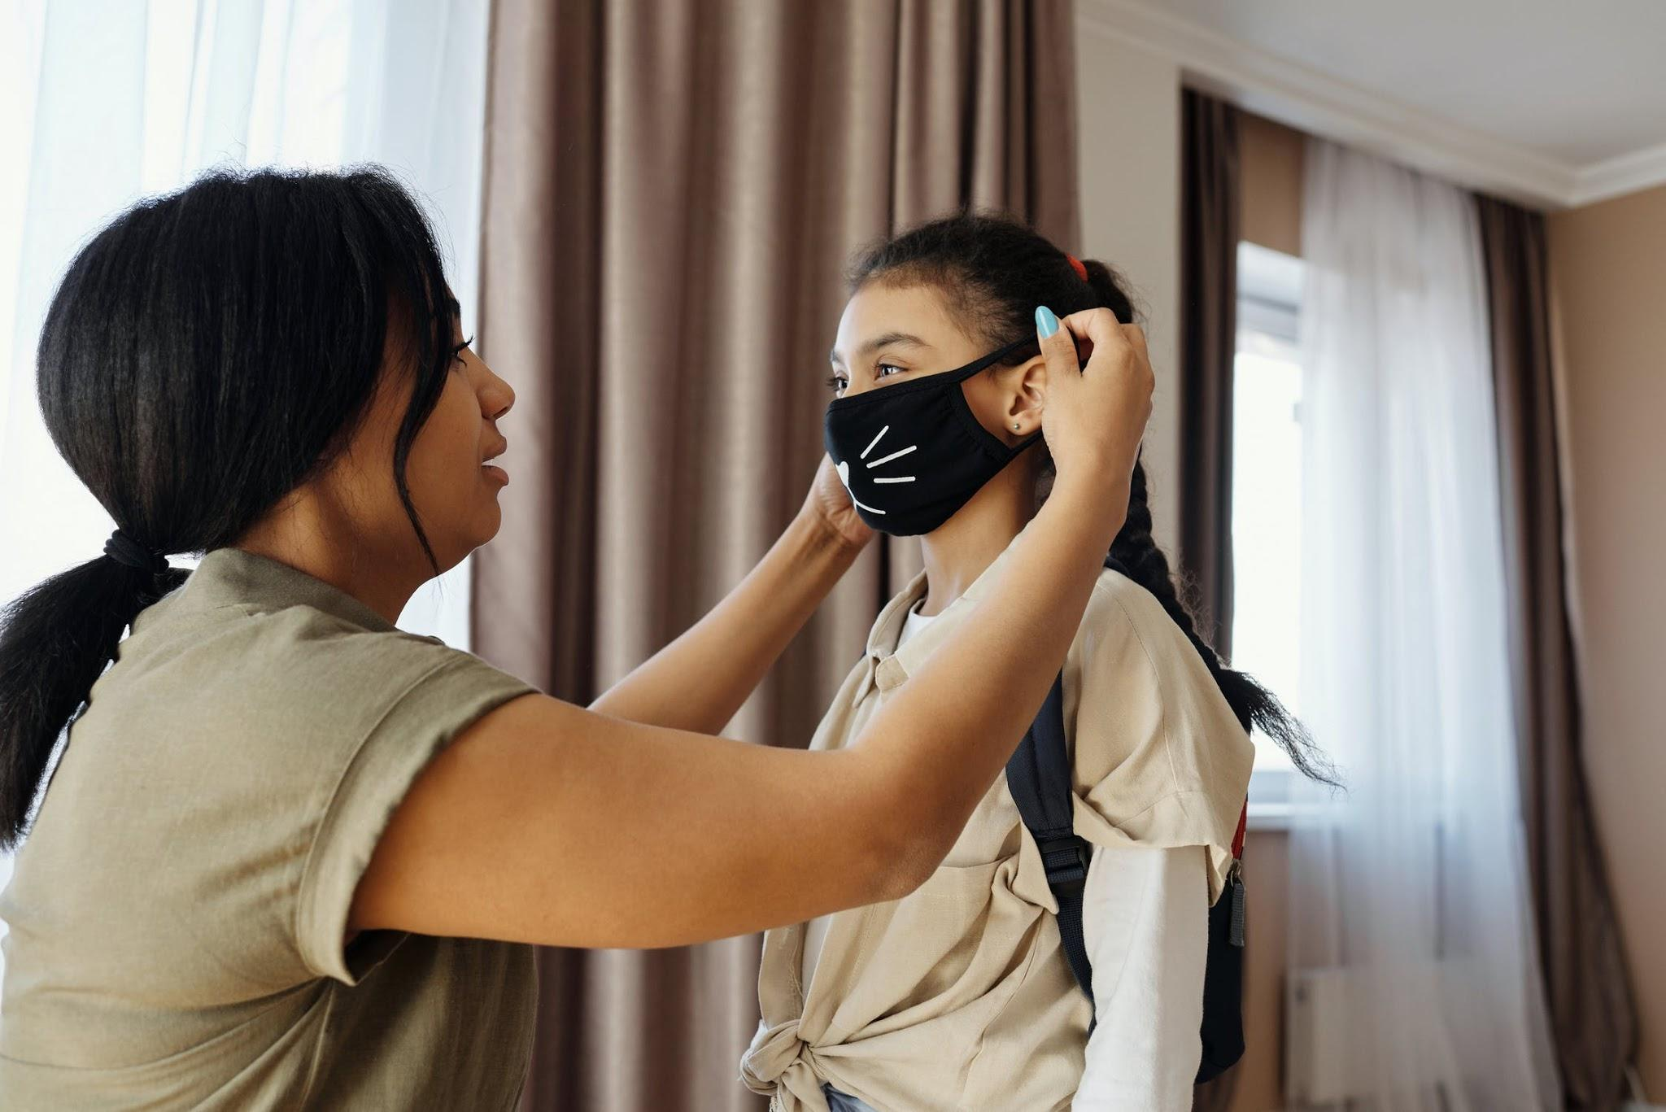

How Doing Your Best as a Migrant Worker During COVID-19 Will Have to Be Enough

It can be safely surmised that migrant workers are having the toughest time in this pandemic. Being away from their home countries to work in essential jobs like healthcare has left them vulnerable to infection — yet sans all the support that citizens take for granted. As a result, many migrants are finding themselves completely out of their element, often unsure of how to move forward or even how to somehow ride out the pandemic.

If you’re finding yourself in this less-than-ideal situation, fear not, as there are still ways to get the system to support you for the time being.

Problems You May Be Facing

As a migrant worker far from the comforts and security of your home country, you may feel displaced and uncertain in your adoptive country in this pandemic. This is by no fault of your own as resources for immigrants have proven to be sadly lacking in the time of COVID-19.

- Among the many consequences of the pandemic is the dismal healthcare situation wherein the poor and immigrants are particularly susceptible, thanks to inadequate—or even the complete lack of — health coverage.
- Migrant workers actually make up a considerable percentage of all essential workers in the country, in industries ranging from healthcare to agriculture.
- Essential migrant workers are also ineligible for the many stimulus packages that have been made available of late, so many are feeling disposable and unsure of their survival (often literally) in the pandemic.
- To make matters worse, some races and minority groups are the subjects of widespread racism and xenophobia because of COVID-19’s very nature.

Proactive Steps You Can Take

With the lack of support and resources for migrant workers this pandemic, it’s more than wise to take matters into your own hands. While finding ways to improve and safeguard your current situation at this difficult time can be challenging, it’s still far from insurmountable.

- Theoretically, as a migrant worker, you should be covered by unemployment insurance if you lose your job during the pandemic, so make sure to learn your eligibility.
- You also need to be aware that getting tested and treated for COVID-19 will not and should not count against your chances for a Green Card, as per the USCIS’s announcement on the public charge.
- Do consider hiring an immigration professional such as a lawyer to help with your particular circumstances, but do make sure to check freelancer reviews for trustworthiness and experience.
- Doing your due diligence and learning all about your rights and resources as a migrant worker or immigrant is also necessary, on the federal, state, and local levels.
- There are even foundations and organizations offering emergency funding to immigrants, regardless of status.

Protection for Your Family

As you work hard to strengthen your position, finances, and overall situation amidst the uncertainty of the current crisis, you want to make sure that you don’t neglect the homefront, as well. Ensuring your family’s safety and security from all the world’s threats, especially COVID-19, is still your top priority,

- You have to know what to do if you or a family member gets sick, as well as take measures to protect the rest of your family.
- For parents, finding a babysitter you can trust is of utmost importance while you’re convalescing or even when you’re working.
- Of course, you must keep your home clean and disinfected at all times as this is your family’s best protection against the virus.

Ultimately, the pandemic will come and go, and with life back to normal, these feelings of uncertainty and fear that you feel as you navigate your adoptive country will be but a distant memory. But for now, work hard, stay healthy, and keep yourself informed.

Photo via Pexels.com

